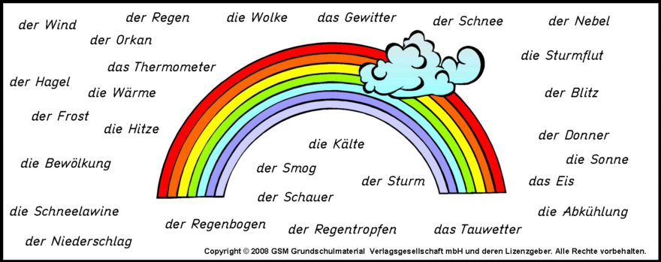
Can you figure out what the above terms mean? Many are cognates. Write them next to their English equivalent below.
- ice _________________________ 15. smog _________________________
- thunder _________________________ 16. thermometer _________________________
- raindrop _________________________ 17. warmth _________________________
- cold _________________________ 18. avalanche _________________________
- frost _________________________ 19. thaw(ing) _________________________
- heat _________________________ 20. fog _________________________
- shower_________________________ 21. snow _________________________
- storm _________________________ 22. thunderstorm _________________________
- rain _________________________ 23. hail _________________________
- wind _________________________ 24. hurricane _________________________
- rainbow _________________________ 25. storm flood _________________________
- cloud _________________________ 26. cloudiness _________________________
- lightning _________________________ 27. cooling down _________________________
- sun _________________________ 28. rainfall/precipitation _________________________

